Resident Evil (1996, PlayStation), Capcom. GAMEPLAY MODE

1. Composition
Tangible space | Full screen. Menus, stats and inventory are in a completely separate view and timeframe
Intangible space | None
Negative Space | None
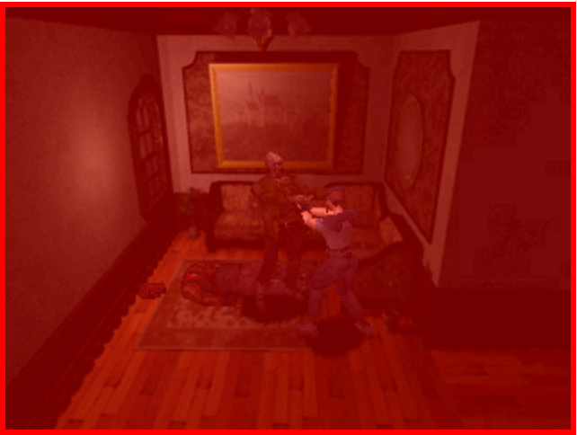
External | Player Tangible
2. Ocularization

3. Framing mechanisms | Anchor : Objective | Mobility : Connected

4. Plane Analysis
 | Agents | In-game | Off-game
Graphical materials | Real-time 3D polygons | Pre-rendered 3D | -
Projection method | Linear | Linear | -
Angle of projection | Various | Various | -

Notes :
The cinematic aesthetic of the survival horror genre is a good, if sometimes subtle, example of a tangible player ocularization. The fixed camera with minimal predetermined pans dramatizes the absence/presence of enemies by way of visual and spatial montage. The player knows that this meta game of incomplete visual information is meant for her worried attention and is not optimal to the task at hand: explore space while avoiding danger.
A paragon of the genre, Resident Evil is a rare case of celebrated sub-optimal ergodic situation where handicap is a positive experience. A similar ergodic struggle awaits players of racing simulations using the “television” camera angles. The camera is connected to the player’s agent, but its movements are mere “cues” to objectively show fragments of game space from arbitrary angles that are rarely if ever the best ones to accomplish navigational and neutralization tasks.

